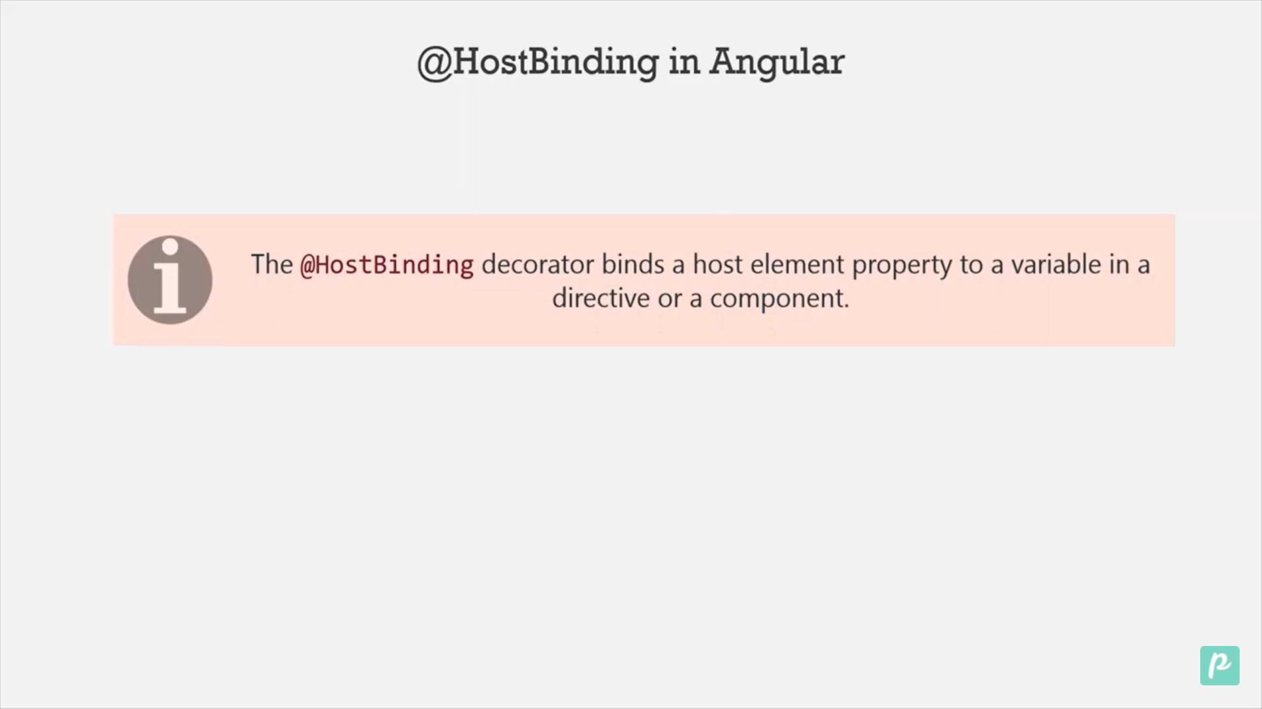

import { Directive, ElementRef, Renderer2, HostBinding } from '@angular/core';

@Directive({

  selector: '[appHostbinding]',

})

export class HostbindingDirective {

  constructor(private element: ElementRef, private render: Renderer2) {}

  @HostBinding('style.color') str: string = 'red';

}

Html

<!-- HostBinding -->

<div appHostbinding>

  <span>

    <h1>

      We will see the use of HostBinding it binds the host html property to

      directive variable

    </h1>

  </span>

</div>

Step 1: Create a directive HostBinding

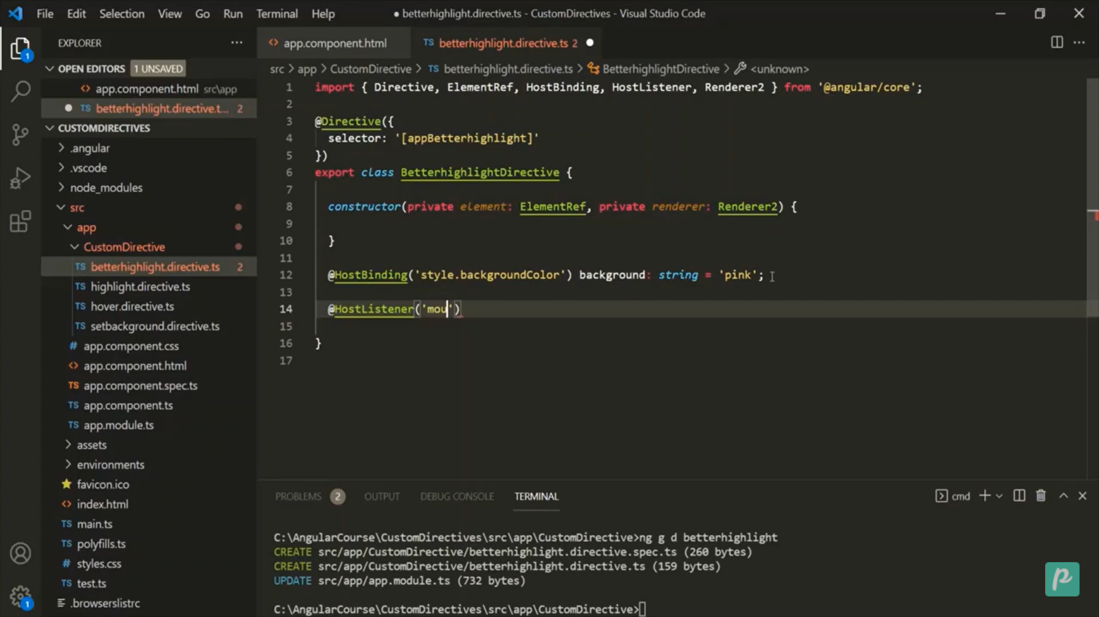



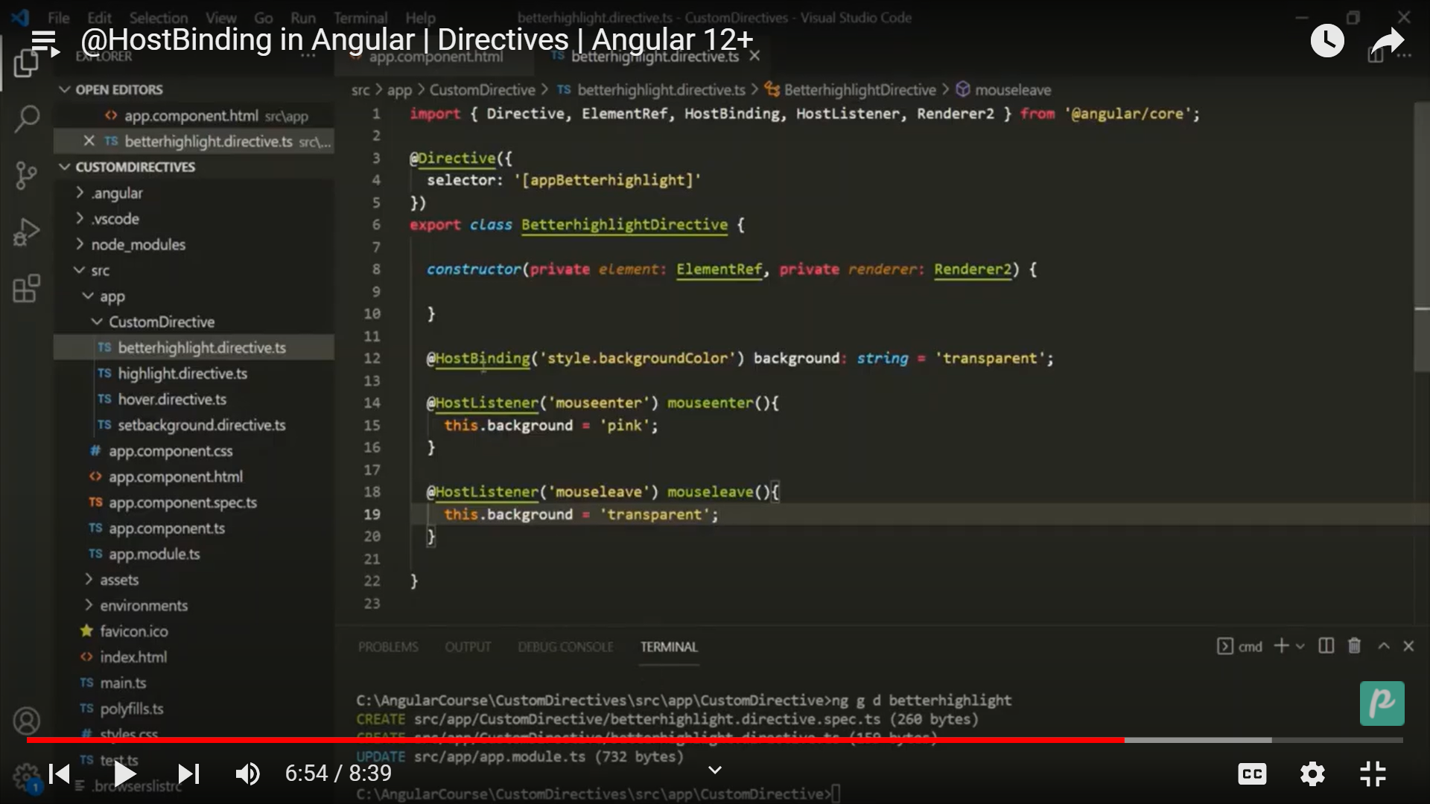

Binding Directives